# Core Mechanics Continued Research

This research focuses purely on innovating on our core mechanic rather than adding new mechanics to the game.

## **Curling**

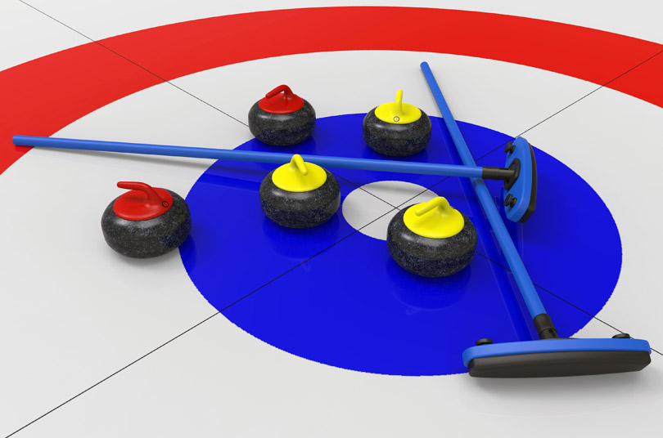

Curling was the first game I looked at. The aim in Curling is to end round with your ‘stones’ placed closest to the center of the rings. This can be can two ways both requiring careful aiming and judgement:

* The first sees the player aim to position their stone closest to the center of the rings.
* The second see the player smashing their stone into the opponent’s stones to knock them away from the center.

## **Aim for the nuts (OMGPOP)**

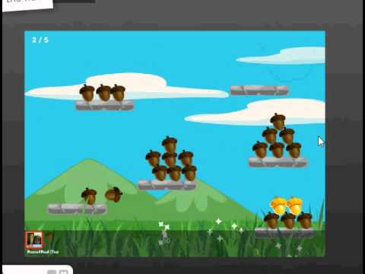

Aim for the nuts is multiplayer arcade style game hosted on omgpop. The goal is to destroy, or knock the scoring items off the playing area.

Key items:

* Different valued scoring items.
* Interesting scoring item shapes.
* Players are independent of each other.
* Power ups/downs between each shot for hitting certain targets.
* Power up/down gives a random effect and can be applied to any player, either giving yourself a power up or another player a power down.

## **Sushi Cat-a-pult**

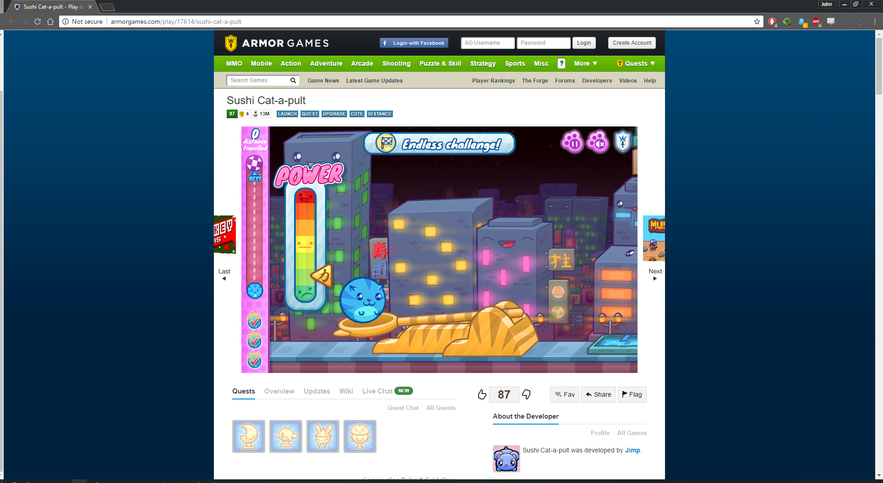Sushi Cat-a-pult is a single player objective based distance game. The player catapualts a cat and times bounces to reach the goal. The goal of each level is to either collect enough sushi or travel a specified distance.

Key items:

* The physics behind the bouncing cat.
* An use effect.
* A longer round based game.

## **Wake the Royalty**

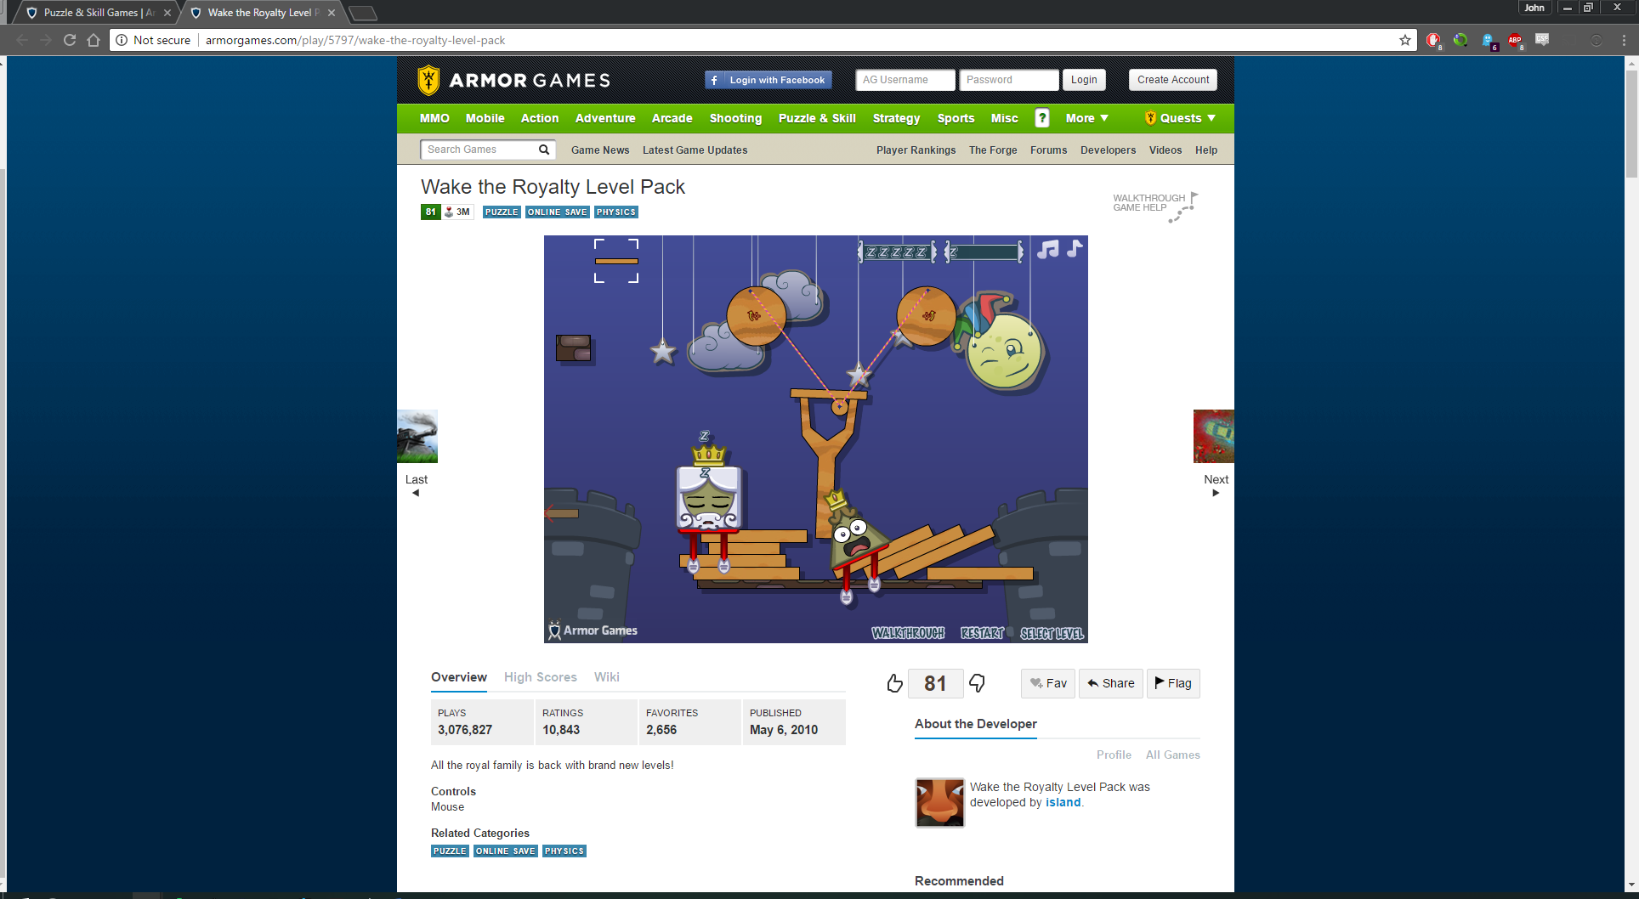

Wake the royalty is a single player level based puzzle game. The player places objects around a scene to offset balance or react to the other moving object. The goal of the game is to wake up, or knock off the ‘Royalty’.

Key items:

* Movable level objects.
* Independently moving level objects.
* Absolute placement of objects.

# **References:**

**Curling**

<https://en.wikipedia.org/wiki/Curling>

**Aim for the nuts**

<https://www.youtube.com/watch?v=LAcWZtFjnRo>

**Sushi Cat-a-pult**

<http://armorgames.com/play/17614/sushi-cat-a-pult>

**Wake the Royalty**

<http://armorgames.com/play/5797/wake-the-royalty-level-pack>